Registration Form
Workshop Theorizing the Body in Health and Medicine

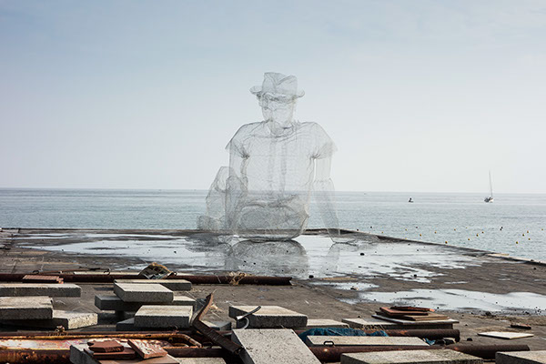

26-27 November 2015
Crowne Plaza Hotel
Maastricht, The Netherlands

Details of Participant:
First name & surname:
Position:
Institute/Organisation:
Postal address of Institute/ Organisation:
Postcode:
Country:
Email address:
Phone No / Fax No:
Participation
☐ I will participate in the workshop on 26-27 November 2015 (40€)
☐ I will participate in the workshop on 26 or 27 November (25€). Please, specify: ………….

Please return before 31 October 2015 by email to Hellen Heutz: h.heutz@maastrichtuniversity.nl
Please note that your registration will be effective upon reception of the registration fees (40€ for two days, 25€ for one day), which can be paid to Maastricht University, IBAN: NL47INGB0657625418, with the reference “t.g.v. ordernr. 30.95.63.13 N”
For further information please visit http://www.mindthebody.eu/

